LAPORAN TUGAS
ASISTENSI ALGORITMA PEMROGRAMAN
“Tugas 2 Asistensi Alpro”



DWI RISMAYANTI
06111840000083

DEPARTEMEN MATEMATIKA
FAKULTAS MATEMATIKA KOMPUTASI DAN SAINS DATA
INSTITUT TEKNOLOGI SEPULUH NOPEMBER
SURABAYA
2019

- SOAL
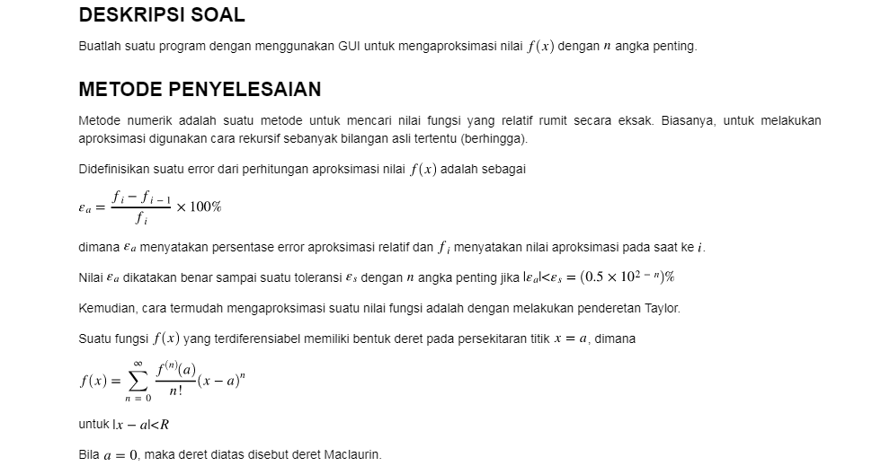

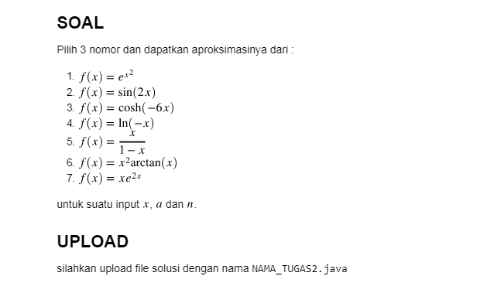

- SOURCE CODE

Program penyelesaian masalah tersebut yaitu:
/*
* To change this license header, choose License Headers in Project Properties.
* To change this template file, choose Tools | Templates
* and open the template in the editor.
*/
import java.util.Scanner;
/**
*
* @author user
*/
public class asis extends javax.swing.JFrame {
private double angka;

/**
* Creates new form asis
*/
public asis() {
initComponents();
}

/**
* This method is called from within the constructor to initialize the form.
* WARNING: Do NOT modify this code. The content of this method is always
* regenerated by the Form Editor.
*/
@SuppressWarnings("unchecked")
// <editor-fold defaultstate="collapsed" desc="Generated Code">//GEN-BEGIN:initComponents
private void initComponents() {

soal = new javax.swing.JTextField();
Soal1 = new javax.swing.JRadioButton();
Soal2 = new javax.swing.JRadioButton();
Soal3 = new javax.swing.JRadioButton();
jLabel1 = new javax.swing.JLabel();
jLabel2 = new javax.swing.JLabel();
jLabel3 = new javax.swing.JLabel();
jLabel4 = new javax.swing.JLabel();
hitung = new javax.swing.JButton();
reset = new javax.swing.JButton();
texta = new javax.swing.JTextField();
textn = new javax.swing.JTextField();
textx = new javax.swing.JTextField();
jLabel5 = new javax.swing.JLabel();
hasiltext = new javax.swing.JTextField();

setDefaultCloseOperation(javax.swing.WindowConstants.EXIT_ON_CLOSE);

soal.addActionListener(new java.awt.event.ActionListener() {
public void actionPerformed(java.awt.event.ActionEvent evt) {
soalActionPerformed(evt);
}
});

Soal1.setText("SOAL 1");
Soal1.addActionListener(new java.awt.event.ActionListener() {
public void actionPerformed(java.awt.event.ActionEvent evt) {
Soal1ActionPerformed(evt);
}
});

Soal2.setText("SOAL 2");
Soal2.addActionListener(new java.awt.event.ActionListener() {
public void actionPerformed(java.awt.event.ActionEvent evt) {
Soal2ActionPerformed(evt);
}
});

Soal3.setText("SOAL 3");
Soal3.addActionListener(new java.awt.event.ActionListener() {
public void actionPerformed(java.awt.event.ActionEvent evt) {
Soal3ActionPerformed(evt);
}
});

jLabel1.setText("MASUKKAN NILAI");

jLabel2.setText("a");

jLabel3.setText("n");

jLabel4.setText("x");

hitung.setText("HITUNG");
hitung.addActionListener(new java.awt.event.ActionListener() {
public void actionPerformed(java.awt.event.ActionEvent evt) {
hitungActionPerformed(evt);
}
});

reset.setText("RESET");
reset.addActionListener(new java.awt.event.ActionListener() {
public void actionPerformed(java.awt.event.ActionEvent evt) {
resetActionPerformed(evt);
}
});

texta.addActionListener(new java.awt.event.ActionListener() {
public void actionPerformed(java.awt.event.ActionEvent evt) {
textaActionPerformed(evt);
}
});

textn.addActionListener(new java.awt.event.ActionListener() {
public void actionPerformed(java.awt.event.ActionEvent evt) {
textnActionPerformed(evt);
}
});

textx.addActionListener(new java.awt.event.ActionListener() {
public void actionPerformed(java.awt.event.ActionEvent evt) {
textxActionPerformed(evt);
}
});

jLabel5.setText("HASIL =");

hasiltext.addActionListener(new java.awt.event.ActionListener() {
public void actionPerformed(java.awt.event.ActionEvent evt) {
hasiltextActionPerformed(evt);
}
});

javax.swing.GroupLayout layout = new javax.swing.GroupLayout(getContentPane());
getContentPane().setLayout(layout);
layout.setHorizontalGroup(
layout.createParallelGroup(javax.swing.GroupLayout.Alignment.LEADING)
.addGroup(layout.createSequentialGroup()
.addGap(25, 25, 25)
.addComponent(hitung)
.addGap(29, 29, 29)
.addComponent(reset))
.addGroup(layout.createSequentialGroup()
.addGroup(layout.createParallelGroup(javax.swing.GroupLayout.Alignment.LEADING)
.addGroup(layout.createSequentialGroup()
.addGap(26, 26, 26)
.addComponent(jLabel1)
.addGap(0, 0, Short.MAX_VALUE))
.addGroup(layout.createSequentialGroup()
.addGroup(layout.createParallelGroup(javax.swing.GroupLayout.Alignment.LEADING)
.addGroup(layout.createSequentialGroup()
.addGap(26, 26, 26)
.addGroup(layout.createParallelGroup(javax.swing.GroupLayout.Alignment.TRAILING)
.addComponent(jLabel3)
.addComponent(jLabel2)
.addComponent(jLabel4)))
.addGroup(layout.createSequentialGroup()
.addContainerGap()
.addComponent(jLabel5)))
.addGroup(layout.createParallelGroup(javax.swing.GroupLayout.Alignment.LEADING)
.addGroup(layout.createSequentialGroup()
.addPreferredGap(javax.swing.LayoutStyle.ComponentPlacement.RELATED)
.addGroup(layout.createParallelGroup(javax.swing.GroupLayout.Alignment.LEADING)
.addComponent(textx, javax.swing.GroupLayout.PREFERRED_SIZE, 52, javax.swing.GroupLayout.PREFERRED_SIZE)
.addGroup(layout.createParallelGroup(javax.swing.GroupLayout.Alignment.LEADING, false)
.addComponent(textn, javax.swing.GroupLayout.DEFAULT_SIZE, 53, Short.MAX_VALUE)
.addComponent(texta)))
.addPreferredGap(javax.swing.LayoutStyle.ComponentPlacement.RELATED, 329, Short.MAX_VALUE)
.addGroup(layout.createParallelGroup(javax.swing.GroupLayout.Alignment.LEADING)
.addComponent(Soal2, javax.swing.GroupLayout.Alignment.TRAILING)
.addComponent(Soal1, javax.swing.GroupLayout.Alignment.TRAILING)
.addComponent(Soal3, javax.swing.GroupLayout.Alignment.TRAILING))
.addGap(27, 27, 27)
.addComponent(soal, javax.swing.GroupLayout.PREFERRED_SIZE, 93, javax.swing.GroupLayout.PREFERRED_SIZE))
.addGroup(layout.createSequentialGroup()
.addGap(21, 21, 21)
.addComponent(hasiltext, javax.swing.GroupLayout.PREFERRED_SIZE, 52, javax.swing.GroupLayout.PREFERRED_SIZE)
.addGap(0, 0, Short.MAX_VALUE)))))
.addContainerGap())
);
layout.setVerticalGroup(
layout.createParallelGroup(javax.swing.GroupLayout.Alignment.LEADING)
.addGroup(layout.createSequentialGroup()
.addContainerGap(127, Short.MAX_VALUE)
.addComponent(jLabel1)
.addPreferredGap(javax.swing.LayoutStyle.ComponentPlacement.RELATED)
.addGroup(layout.createParallelGroup(javax.swing.GroupLayout.Alignment.LEADING)
.addGroup(layout.createSequentialGroup()
.addGroup(layout.createParallelGroup(javax.swing.GroupLayout.Alignment.LEADING)
.addGroup(layout.createSequentialGroup()
.addGap(6, 6, 6)
.addComponent(soal, javax.swing.GroupLayout.PREFERRED_SIZE, 118, javax.swing.GroupLayout.PREFERRED_SIZE))
.addGroup(layout.createSequentialGroup()
.addGroup(layout.createParallelGroup(javax.swing.GroupLayout.Alignment.LEADING)
.addGroup(layout.createSequentialGroup()
.addComponent(Soal1)
.addGap(18, 18, 18)
.addComponent(Soal2))
.addGroup(layout.createSequentialGroup()
.addGroup(layout.createParallelGroup(javax.swing.GroupLayout.Alignment.BASELINE)
.addComponent(jLabel2)
.addComponent(texta, javax.swing.GroupLayout.PREFERRED_SIZE, javax.swing.GroupLayout.DEFAULT_SIZE, javax.swing.GroupLayout.PREFERRED_SIZE))
.addGap(18, 18, 18)
.addGroup(layout.createParallelGroup(javax.swing.GroupLayout.Alignment.BASELINE)
.addComponent(textn, javax.swing.GroupLayout.PREFERRED_SIZE, javax.swing.GroupLayout.DEFAULT_SIZE, javax.swing.GroupLayout.PREFERRED_SIZE)
.addComponent(jLabel3))))
.addGap(18, 18, 18)
.addGroup(layout.createParallelGroup(javax.swing.GroupLayout.Alignment.LEADING)
.addComponent(Soal3)
.addGroup(layout.createSequentialGroup()
.addGroup(layout.createParallelGroup(javax.swing.GroupLayout.Alignment.BASELINE)
.addComponent(textx, javax.swing.GroupLayout.PREFERRED_SIZE, javax.swing.GroupLayout.DEFAULT_SIZE, javax.swing.GroupLayout.PREFERRED_SIZE)
.addComponent(jLabel4, javax.swing.GroupLayout.PREFERRED_SIZE, 14, javax.swing.GroupLayout.PREFERRED_SIZE))
.addGap(49, 49, 49)
.addGroup(layout.createParallelGroup(javax.swing.GroupLayout.Alignment.BASELINE)
.addComponent(jLabel5)
.addComponent(hasiltext, javax.swing.GroupLayout.PREFERRED_SIZE, javax.swing.GroupLayout.DEFAULT_SIZE, javax.swing.GroupLayout.PREFERRED_SIZE))))))
.addContainerGap(158, Short.MAX_VALUE))
.addGroup(javax.swing.GroupLayout.Alignment.TRAILING, layout.createSequentialGroup()
.addGap(207, 207, 207)
.addGroup(layout.createParallelGroup(javax.swing.GroupLayout.Alignment.BASELINE)
.addComponent(reset)
.addComponent(hitung))
.addContainerGap())))
);

pack();
}// </editor-fold>//GEN-END:initComponents

private void soalActionPerformed(java.awt.event.ActionEvent evt) {//GEN-FIRST:event_soalActionPerformed
// TODO add your handling code here:
}//GEN-LAST:event_soalActionPerformed

private void resetActionPerformed(java.awt.event.ActionEvent evt) {//GEN-FIRST:event_resetActionPerformed
// TODO add your handling code here:
}//GEN-LAST:event_resetActionPerformed

private void Soal1ActionPerformed(java.awt.event.ActionEvent evt) {//GEN-FIRST:event_Soal1ActionPerformed
soal.setText("f(x) = sin (2x)"); // TODO add your handling code here:
}//GEN-LAST:event_Soal1ActionPerformed

private void Soal2ActionPerformed(java.awt.event.ActionEvent evt) {//GEN-FIRST:event_Soal2ActionPerformed
soal.setText("f(x) = x/(1-x)"); // TODO add your handling code here:
}//GEN-LAST:event_Soal2ActionPerformed

private void Soal3ActionPerformed(java.awt.event.ActionEvent evt) {//GEN-FIRST:event_Soal3ActionPerformed
soal.setText("f(x) = xe^2x"); // TODO add your handling code here:
}//GEN-LAST:event_Soal3ActionPerformed

private void hitungActionPerformed(java.awt.event.ActionEvent evt) {//GEN-FIRST:event_hitungActionPerformed
// TODO add your handling code here:
//hitung
double n=Double.parseDouble(textn.getText());
double a=Double.parseDouble(texta.getText());
double x=Double.parseDouble(textx.getText());
double hasil=0;
double hasil1=0;
int apa=1;
double faktorial=1;
for(int i=1;i<=n;i++)
{
faktorial=faktorial*i;
apa++;
}
if("f(x) = sin (2x)".equals(soal.getText()))
{
for(int i=0;i<=n;i++)
{
hasil=hasil+(Math.pow(2,i) * Math.pow(x,i) * Math.pow(-1,i))/faktorial;
}
}
if("f(x) = x/(1-x)".equals(soal.getText()))
{
for(int i=0;i<=n;i++)
{
hasil1 = n*Math.pow(x,i+1);
hasil= hasil+hasil1;
}
}
hasiltext.setText(String.valueOf(hasil));
}//GEN-LAST:event_hitungActionPerformed

private void textnActionPerformed(java.awt.event.ActionEvent evt) {//GEN-FIRST:event_textnActionPerformed
// TODO add your handling code here:
double n;
Scanner input = new Scanner(System.in);
n = input.nextDouble();
}//GEN-LAST:event_textnActionPerformed

private void hasiltextActionPerformed(java.awt.event.ActionEvent evt) {//GEN-FIRST:event_hasiltextActionPerformed
// TODO add your handling code here:
//hasil

}//GEN-LAST:event_hasiltextActionPerformed

private void textaActionPerformed(java.awt.event.ActionEvent evt) {//GEN-FIRST:event_textaActionPerformed
// TODO add your handling code here:
double a;
Scanner input = new Scanner(System.in);
a = input.nextDouble();
// jLabel1.setText(a);

}//GEN-LAST:event_textaActionPerformed

private void textxActionPerformed(java.awt.event.ActionEvent evt) {//GEN-FIRST:event_textxActionPerformed
// TODO add your handling code here:
double x;
Scanner input = new Scanner(System.in);
x = input.nextDouble();
}//GEN-LAST:event_textxActionPerformed

/**
* @param args the command line arguments
*/
public static void main(String args[]) {
/* Set the Nimbus look and feel */
//<editor-fold defaultstate="collapsed" desc=" Look and feel setting code (optional) ">
/* If Nimbus (introduced in Java SE 6) is not available, stay with the default look and feel.
* For details see http://download.oracle.com/javase/tutorial/uiswing/lookandfeel/plaf.html
*/
try {
for (javax.swing.UIManager.LookAndFeelInfo info : javax.swing.UIManager.getInstalledLookAndFeels()) {
if ("Nimbus".equals(info.getName())) {
javax.swing.UIManager.setLookAndFeel(info.getClassName());
break;
}
}
} catch (ClassNotFoundException ex) {
java.util.logging.Logger.getLogger(asis.class.getName()).log(java.util.logging.Level.SEVERE, null, ex);
} catch (InstantiationException ex) {
java.util.logging.Logger.getLogger(asis.class.getName()).log(java.util.logging.Level.SEVERE, null, ex);
} catch (IllegalAccessException ex) {
java.util.logging.Logger.getLogger(asis.class.getName()).log(java.util.logging.Level.SEVERE, null, ex);
} catch (javax.swing.UnsupportedLookAndFeelException ex) {
java.util.logging.Logger.getLogger(asis.class.getName()).log(java.util.logging.Level.SEVERE, null, ex);
}
//</editor-fold>

/* Create and display the form */
java.awt.EventQueue.invokeLater(new Runnable() {
public void run() {
new asis().setVisible(true);
}
});
}

// Variables declaration - do not modify//GEN-BEGIN:variables
private javax.swing.JRadioButton Soal1;
private javax.swing.JRadioButton Soal2;
private javax.swing.JRadioButton Soal3;
private javax.swing.JTextField hasiltext;
private javax.swing.JButton hitung;
private javax.swing.JLabel jLabel1;
private javax.swing.JLabel jLabel2;
private javax.swing.JLabel jLabel3;
private javax.swing.JLabel jLabel4;
private javax.swing.JLabel jLabel5;
private javax.swing.JButton reset;
private javax.swing.JTextField soal;
private javax.swing.JTextField texta;
private javax.swing.JTextField textn;
private javax.swing.JTextField textx;
// End of variables declaration//GEN-END:variables
}

- RUNNING PROGRAM

Hasil outputan dari beberapa input yang dimasukkan dalam program yaitu:
